Web Tech Lab Question 1

23th August 2024

Question:

Make 5 different web pages out of which first page is your home page with links to other four pages.

SOURCE CODE:

index.html

<!DOCTYPE html>

<html lang="en">

<head>

    <meta charset="UTF-8">

    <meta name="viewport" content="width=device-width, initial-scale=1.0">

    <title>Lab Assignment 1</title>

</head>

<body background="./HTML 5 BG.jfif" style="background-repeat: no-repeat; background-size:cover;">

    <marquee style="font-size:50px;">HTML TUTORIAL</marquee>

    <br><br>

    <div align="center" style="font-size:20px;">

        <br>

       <i> <a href="./page2.html"> Redirect to Page 2</a></i> <br>

       <i> <a href="./page3.html"> Redirect to Page 3</a></i> <br>

       <i> <a href="./page4.html"> Redirect to Page 4</a></i> <br>

       <i> <a href="./page5.html"> Redirect to Page 5</a></i> <br>

    </div>

</body>

</html>

page2.html

<!DOCTYPE html>

<html lang="en">

<head>

    <meta charset="UTF-8">

    <meta name="viewport" content="width=device-width, initial-scale=1.0">

    <title>Page 2</title>

</head>

<body background="./Page2 BG.jfif" style="background-repeat: no-repeat; background-size:cover;">

    <h2 style="font-size:50px;"align="center">This is Page 2 </h2>

    <div align="center" style="font-size:20px;">

        <a href="./index.html"> Redirect to Home Page</a> <br>

        <a href="./page3.html"> Redirect to Page 3</a> <br>

        <a href="./page4.html"> Redirect to Page 4</a> <br>

        <a href="./page5.html"> Redirect to Page 5</a> <br>

    </div>

</body>

</html>

page3.html

<!DOCTYPE html>

<html lang="en">

<head>

    <meta charset="UTF-8">

    <meta name="viewport" content="width=device-width, initial-scale=1.0">

    <title>Page 3</title>

</head>

<body background="./page3 BG.png" style="background-repeat: no-repeat; background-size:cover;">

    <h2 style="font-size:50px;" align="center">This is Page 3 </h2>

    <div align="center" style="font-size:20px;">

        <a href="./index.html"> Redirect to Home Page</a> <br>

        <a href="./page2.html"> Redirect to Page 2</a> <br>

        <a href="./page4.html"> Redirect to Page 4</a> <br>

        <a href="./page5.html"> Redirect to Page 5</a> <br>

    </div>

</body>

</html>

page4.html

<!DOCTYPE html>

<html lang="en">

<head>

    <meta charset="UTF-8">

    <meta name="viewport" content="width=device-width, initial-scale=1.0">

    <title>Page 4</title>

</head>

<body background="./page4 BG.png" style="background-repeat: no-repeat; background-size:cover;">

    <h2 style="font-size:50px;"align="center">This is Page 4 </h2>

    <div align="center" style="font-size:20px;">

        <a href="./index.html"> Redirect to Home Page</a> <br>

        <a href="./page2.html"> Redirect to Page 2</a> <br>

        <a href="./page3.html"> Redirect to Page 3</a> <br>

        <a href="./page5.html"> Redirect to Page 5</a> <br>

    </div>

</body>

</html>

page5.html

<!DOCTYPE html>

<html lang="en">

<head>

    <meta charset="UTF-8">

    <meta name="viewport" content="width=device-width, initial-scale=1.0">

    <title>Page 5</title>

</head>

<body background="./page5 BG.png" style="background-repeat: no-repeat; background-size:cover;">

    <h2 style="font-size:50px;"align="center">This is Page 5 </h2>

    <div align="center" style="font-size:20px;">

        <a href="./index.html"> Redirect to Home Page</a> <br>

        <a href="./page2.html"> Redirect to Page 2</a> <br>

        <a href="./page3.html"> Redirect to Page 3</a> <br>

        <a href="./page4.html"> Redirect to Page 4</a> <br>

    </div>

</body>

</html>

OUTPUT:

|  |  |
| --- | --- |
|  |  |
|  |  |
|  |  |
|  |  |
|  |  |

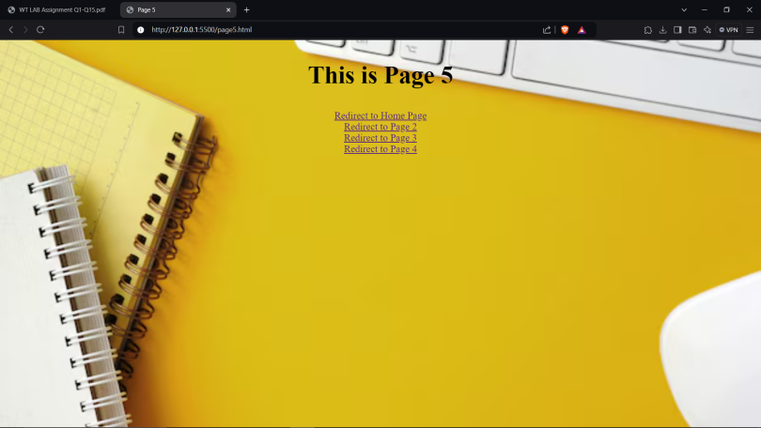

Web Tech Lab Question 2

30th August 2024

Question:

Create an unordered list nested inside ordered list and apply the following:

* Insert an image of Main item on top right corner of web page.
* Display heading as Marquee. •
* Use different font styles and colors for different ordered list items.
* Insert Horizontal lines after each ordered item.

OUTPUT:

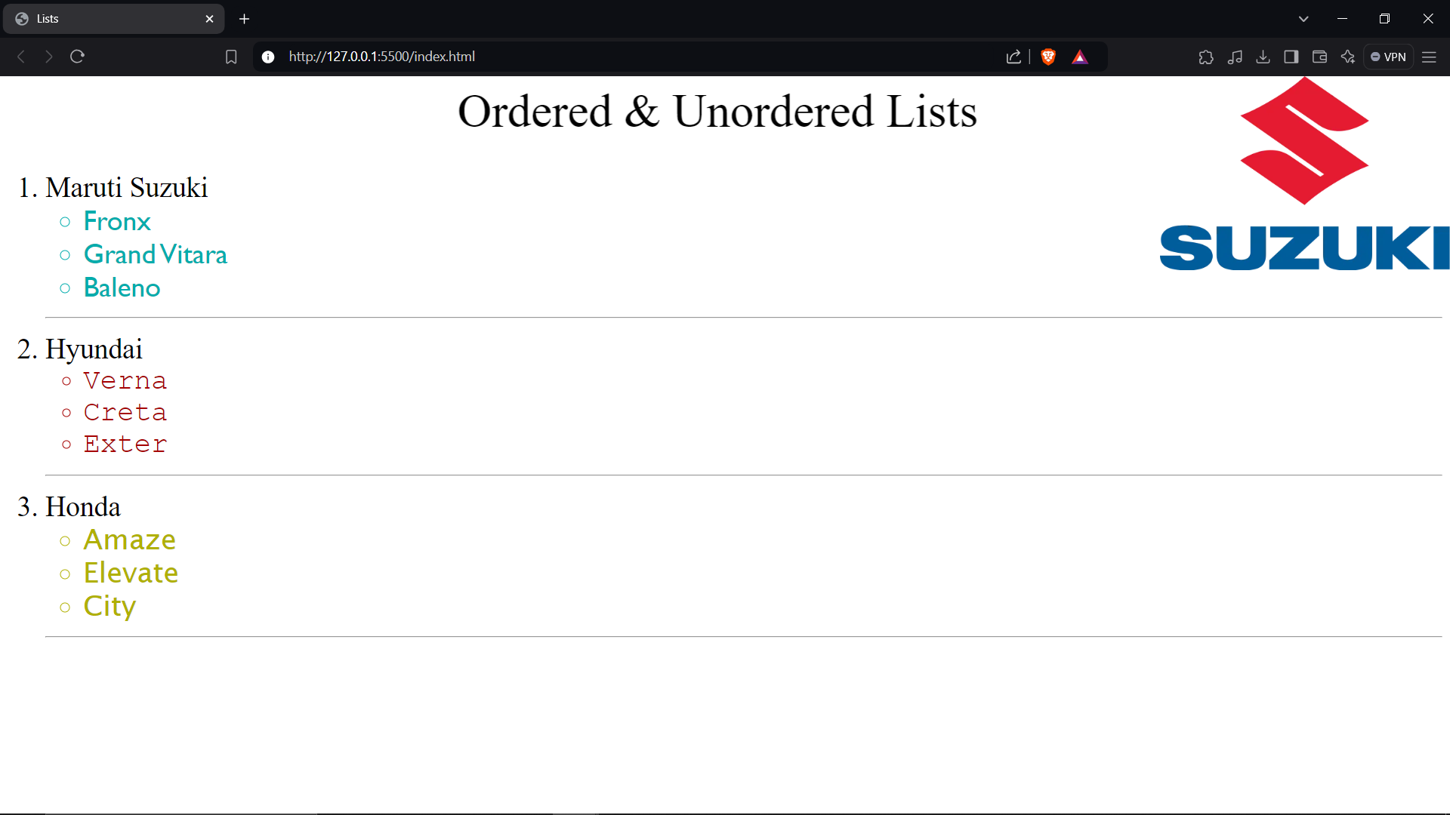

SOURCE CODE:

index.html

<!DOCTYPE html>

<html lang="en">

<head>

    <meta charset="UTF-8">

    <meta name="viewport" content="width=device-width, initial-scale=1.0">

    <title>Lists</title>

</head>

<body background="./Maruti Suzuki Logo.webp" style="background-repeat: no-repeat; background-position: top right; background-size: 20%;" >

    <marquee style="font-size:50px;">Ordered & Unordered Lists</marquee>

    <ol style="font-size:30px;">

        <li>Maruti Suzuki</li>

        <ul style="color: rgb(0, 172, 172); font-family:'Gill Sans';”>

            <li>Fronx</li>

            <li>Grand Vitara</li>

            <li>Baleno</li>

        </ul>

        <hr>

        <li>Hyundai</li>

        <ul style="color: rgb(165, 0, 0); font-family: 'Courier New';">

            <li>Verna</li>

            <li>Creta</li>

            <li>Exter</li>

        </ul>

        <hr>

        <li>Honda</li>

        <ul style="color: rgb(176, 176, 0); font-family: 'Lucida Sans';">

            <li>Amaze</li>

            <li>Elevate</li>

            <li>City</li>

        </ul>

        <hr>

    </ol>

</body>

</html>

Web Tech Lab Question 3

07th September 2024

Question:

Design a table with row span and column span and make use of attributes colspan, rowspan, width, height, cellpadding, cellspacing etc.

SOURCE CODE:

<!DOCTYPE html>

<html lang="en">

<head>

    <meta charset="UTF-8">

    <meta name="viewport" content="width=device-width, initial-scale=1.0">

    <title>Table with Attributes</title>

</head>

<body>

    <marquee style="font-size:50px;">Ordered & Unordered Lists</marquee>

    <table border="1px" align="center" width="300px" height="200px">

        <tr>

            <th colspan="3">Information</th>

        </tr>

        <tr align="center">

            <th rowspan="2">Data</th>

            <td>Saksham S.</td>

            <td>353</td>

        </tr>

        <tr align="center">

            <td>Someone</td>

            <td>Some Rank</td>

        </tr>

    </table>

</body>

</html>

OUTPUT:

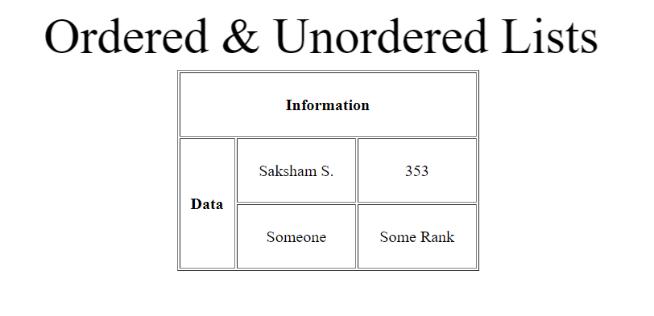

Web Tech Lab Question 4

10th September 2024

Question:

Design the following frame using HTML and CSS.

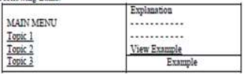

SOURCE CODE:

index.html

<!DOCTYPE html>

<html lang="en">

<head>

    <meta charset="UTF-8">

    <meta name="viewport" content="width=device-width, initial-scale=1.0">

    <title>Creating Frames</title>

</head>

<frameset cols="*,*">

    <frame src="./page1.html">

    <frameset rows="80,20">

        <frame src="./page2.html">

        <frame src="./page3.html">

    </frameset>

</frameset>

<body>

</body>

</html>

page1.html

<!DOCTYPE html>

<html lang="en">

<head>

    <meta charset="UTF-8">

    <meta name="viewport" content="width=device-width, initial-scale=1.0">

    <title>page1</title>

</head>

<body style="font-size: 100px;">

    <p>MAIN MENU</p>

    <a href="https://gradstudies.musc.edu/about/blog/2021/09/covid19-and-its-variants" target="_blank">Topic 1</a> <br>

    <a href="https://www.worldometers.info/coronavirus/country/india/" target="_blank">Topic 2</a><br>

    <a href="https://www.pnbmetlife.com/articles/health/precautions-to-be-taken-in-covid-19- pandemic.html" target="_blank">Topic 3</a>

</body>

</html>

page2.html

<!DOCTYPE html>

<html lang="en">

<head>

    <meta charset="UTF-8">

    <meta name="viewport" content="width=device-width, initial-scale=1.0">

    <title>page2</title>

</head>

<body style="font-size: 65px;">

    <p>Explanations</p>

    <p>------------</p>

    <p>------------</p>

    <p><u>View Example</u></p>

</body>

</html>

page3.html

<!DOCTYPE html>

<html lang="en">

<head>

    <meta charset="UTF-8">

    <meta name="viewport" content="width=device-width, initial-scale=1.0">

    <title>page3</title>

</head>

<body>

    <p style="text-align: center; font-size: 50px;">EXAMPLE</p>

</body>

</html>

OUTPUT:

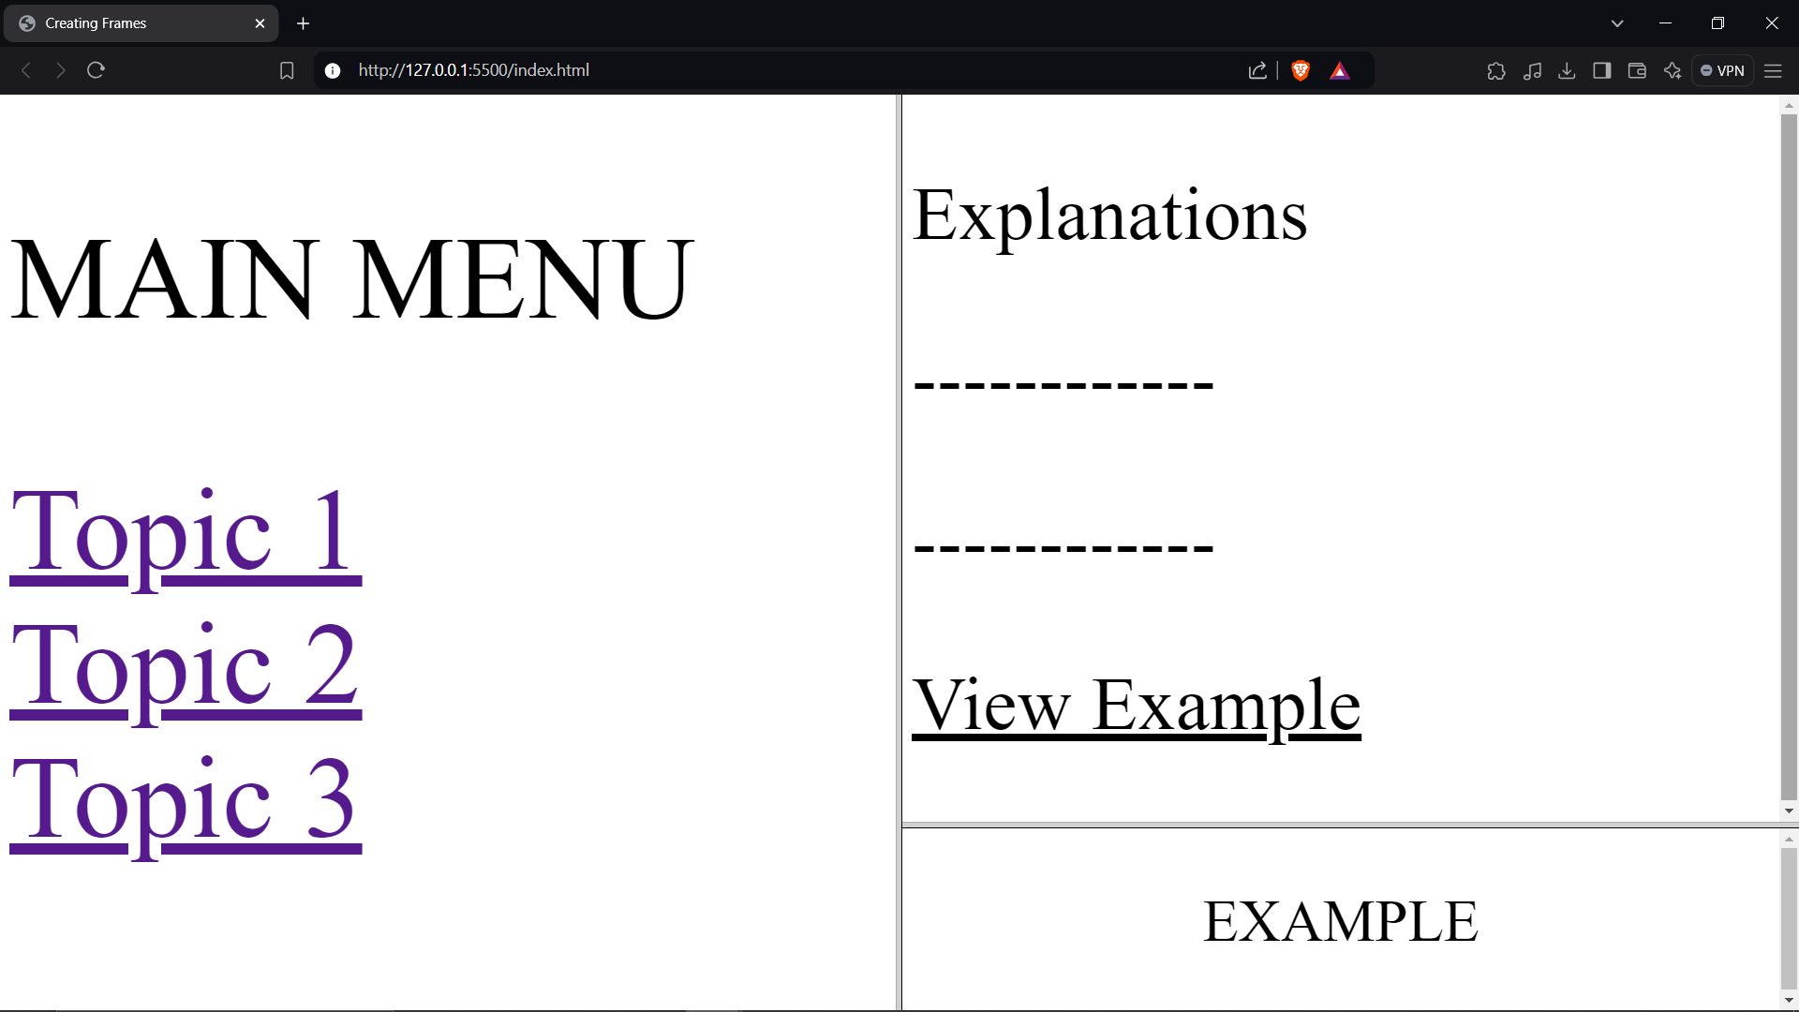

Web Tech Lab Question 5

22th September 2024

Question:

Make an image map showing the usage of shape, cords, href attributes in map. Link each hot-spot to their respective details. All the web pages should be designed with proper background color, images, font styles and headings.

OUTPUT:

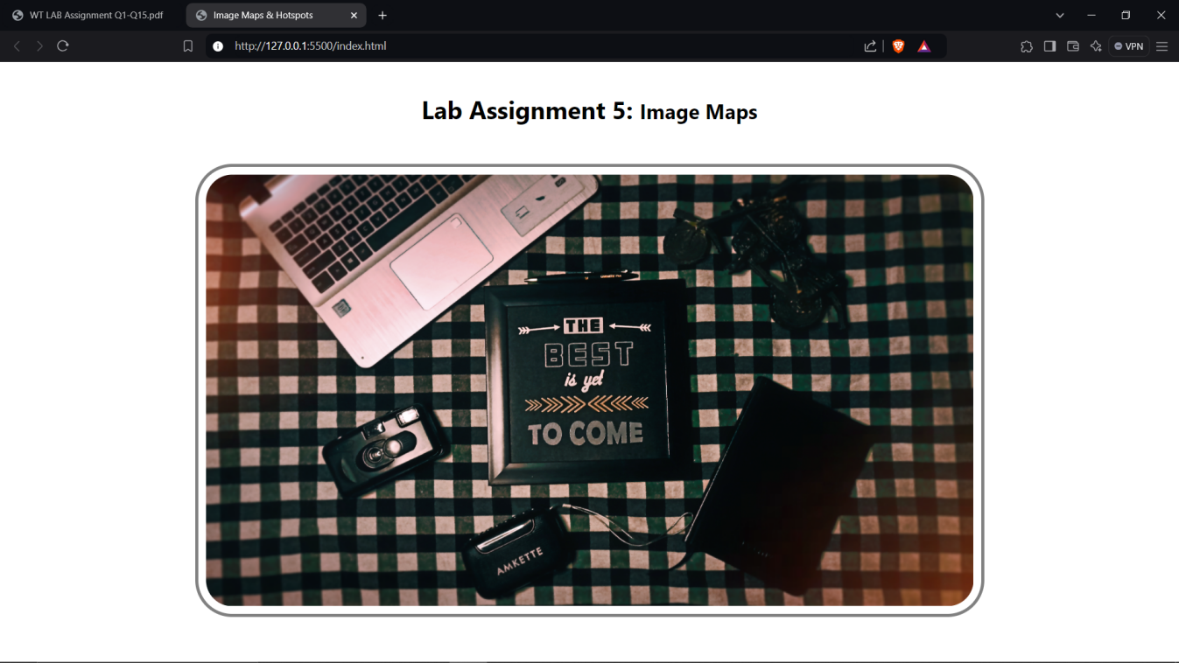



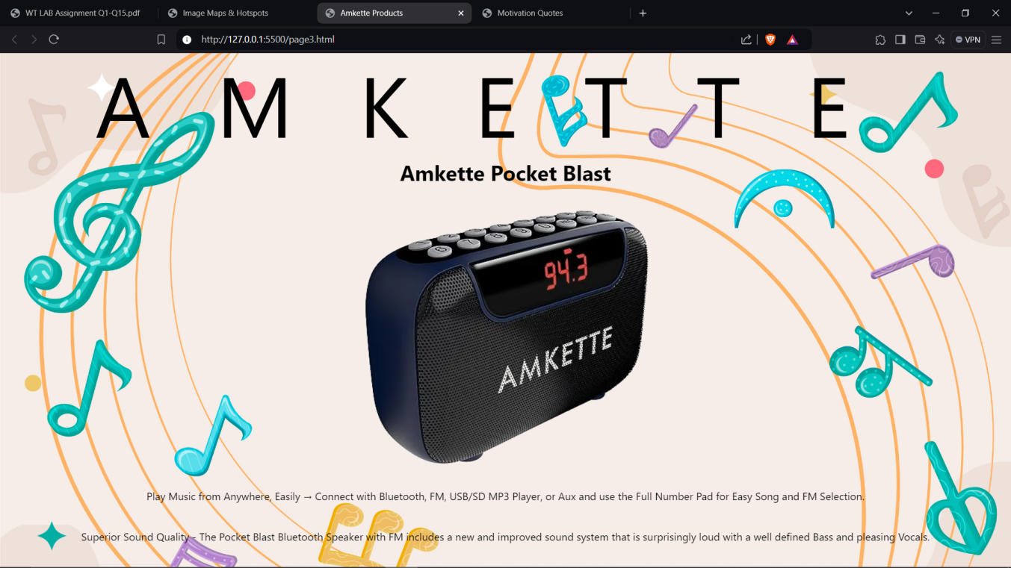

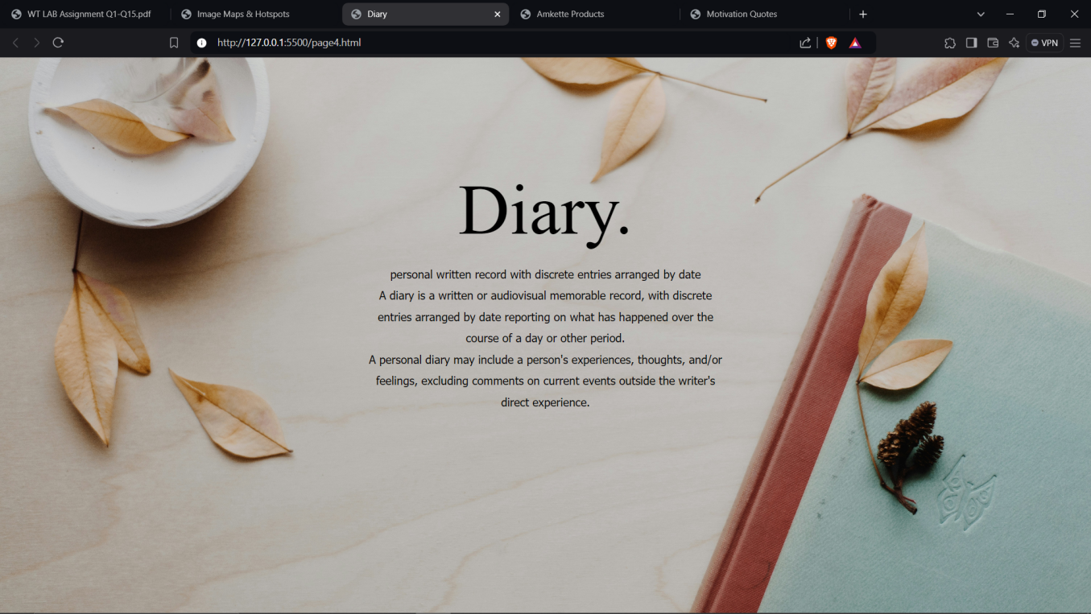

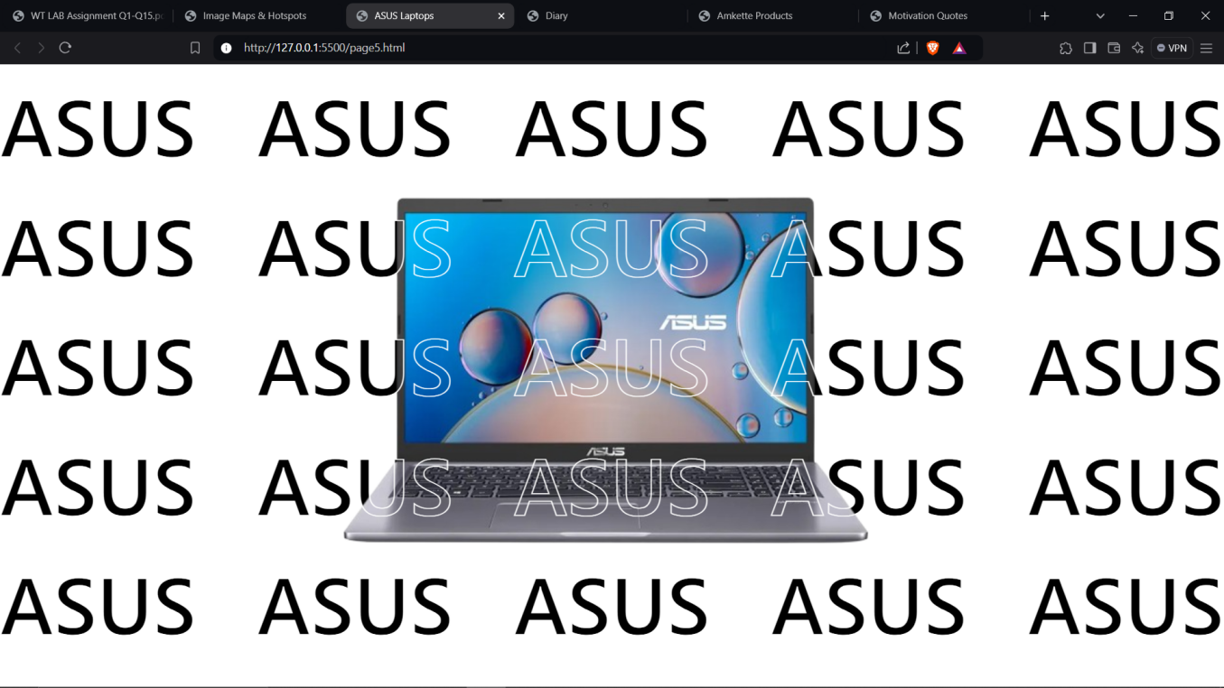

SOURCE CODE:

HTML

index.html

<!DOCTYPE html>

<html lang="en">

<head>

    <meta charset="UTF-8">

    <meta name="viewport" content="width=device-width, initial-scale=1.0">

    <title>Image Maps & Hotspots</title>

    <link rel="stylesheet" href="style.css">

</head>

<body id="indexPage">

    <h1 class="text">Lab Assignment 5: <small>Image Maps</small></h1>

    <map name="flatLay">

        <area shape="rect"

        coords="375,158,645,416"

        href="./page2.html"

        target="_blank">

        <area shape="poly"

        coords="383,494,434,432,478,527,363,652,333,514"

        href="./page3.html"

        target="_blank">

        <area shape="poly"

        coords="740,262,915,336,806,552,654,478"

        href="./page4.html"

        target="_blank">

        <area shape="poly"

        coords="0,9,236,295,544,56,505,0"

        href="./page5.html"

        target="_blank">

    </map>

    <img usemap="#flatLay" src="./Flat Lay.png" alt="Flat Lay" usemap="flatLay" id="mainImg">

</body>

</html>

page2.html

<!DOCTYPE html>

<html lang="en">

<head>

    <meta charset="UTF-8">

    <meta name="viewport" content="width=device-width, initial-scale=1.0">

    <title>Motivation Quotes</title>

    <link rel="stylesheet" href="style.css">

</head>

<body id="page2">

    <h1 class="text">Motivational Quotes</h1>

    <p class="text quotes"> The Best is Yet to Come</p>

    <p class="text quotes"> Believe in the magic of new beginnings.</p>

    <p class="text quotes"> Great things never came from comfort zones.</p>

    <p class="text quotes"> The best chapters of your life are yet to be written.</p>

</body>

</html>

page3.html

<!DOCTYPE html>

<html lang="en">

<head>

    <meta charset="UTF-8">

    <meta name="viewport" content="width=device-width, initial-scale=1.0">

    <title>Amkette Products</title>

    <link rel="stylesheet" href="style.css">

</head>

<body id="page3">

    <pre class="text amketteFont">AMKETTE</pre>

    <h1 class="text">Amkette Pocket Blast</h1>

    <img id="amketteImg" src="./Amkette.png" alt="Amkette">

    <p class="text">Play Music from Anywhere, Easily → Connect with Bluetooth, FM, USB/SD MP3 Player, or Aux and use the Full Number Pad for Easy Song and FM Selection.</p>

    <p class="text">Superior Sound Quality - The Pocket Blast Bluetooth Speaker with FM includes a new and improved sound system that is surprisingly loud with a well defined Bass and pleasing Vocals.</p>

</body>

</html>

page4.html

<!DOCTYPE html>

<html lang="en">

<head>

    <meta charset="UTF-8">

    <meta name="viewport" content="width=device-width, initial-scale=1.0">

    <title>Diary</title>

    <link rel="stylesheet" href="style2.css">

</head>

<body id="page4">

    <div>

        <p class="text diaryMain"> Diary.</p>

        <p class="text">personal written record with discrete entries arranged by date</p>

        <p class="text">A diary is a written or audiovisual memorable record, with discrete entries arranged by date reporting on what has happened over the course of a day or other period.</p>

        <p class="text">A personal diary may include a person's experiences, thoughts, and/or feelings, excluding comments on current events outside the writer's direct experience.</p>

    </div>

</body>

</html>

page5.html

<!DOCTYPE html>

<html lang="en">

<head>

    <meta charset="UTF-8">

    <meta name="viewport" content="width=device-width, initial-scale=1.0">

    <title>ASUS Laptops</title>

    <link rel="stylesheet" href="style2.css">

</head>

<body>

    <p class="text asusR">ASUS ASUS ASUS ASUS ASUS ASUS ASUS ASUS ASUS ASUS ASUS ASUS ASUS ASUS ASUS ASUS ASUS ASUS ASUS ASUS ASUS ASUS ASUS ASUS ASUS ASUS</p>

    <p class="text asusR2">ASUS ASUS ASUS ASUS ASUS ASUS ASUS ASUS ASUS ASUS ASUS ASUS ASUS ASUS ASUS ASUS ASUS ASUS ASUS ASUS ASUS ASUS ASUS ASUS ASUS ASUS</p>

    <img id="asusLPT" src="./asus.png" alt="ASUS LAPTOP">

</body>

</html>

CSS

style.css style2.css

|  |  |
| --- | --- |
| *{      margin: 0%;      padding: 0%;  }  .text{      margin-top: 40px;      text-align: center;      font-family:'Segoe UI', Tahoma, Geneva, Verdana, sans-serif  }  #page2{      background-image: url("./page2\ Bg.jpg");      background-size: cover;  }  #page3{      background-image: url("./music\ Bg.jpg");      background-size: cover;  }  #mainImg{      height: auto;      width: 1000px;      display: block;      margin: 50px auto;      padding: 10px;      border: 4px solid grey;      border-radius: 3rem;  }  .quotes{      font-size: 70px;      line-height: 15vh;      font-family: Impact, Haettenschweiler, 'Arial Narrow Bold', sans-serif !important;  }  .amketteFont{      font-size: 130px;      letter-spacing: 100px;      line-height: 90px;      margin: 30px 0px;  }  #amketteImg{      display: block;      margin: -50px auto;      padding: 10px;      mix-blend-mode:darken  } | *{      margin: 0%;      padding: 0%;  }  body{      overflow: hidden;  }  .text{      line-height: 30px;      text-align: center;      font-family:Tahoma, Geneva, Verdana, sans-serif;  }  #page4{      background-image: url("./diary\ Bg.jpg");      background-size: cover;  }  div{      margin: 200px auto;      width: 500px;  }  .diaryMain{      font-size: 100px;      font-family:'Gill Sans';      margin: 60px 0px;  }  .asusR{      font-family:'Segoe UI', Tahoma, Geneva, Verdana, sans-serif;      font-weight: 500;      font-size: 100px;      line-height: 150px;      text-align: justify;  }  .asusR2{      font-family:'Segoe UI', Tahoma, Geneva, Verdana, sans-serif;      font-weight: 500;      position: absolute;      top: 0;      z-index: 2;      font-size: 100px;      line-height: 150px;      text-align: justify;      -webkit-text-stroke: 1px white;      color: transparent;  }  #asusLPT{      width: 700px;      position: fixed;      z-index: 1;      top: 15vh;      left: 27vw;  } |

Web Tech Lab Question 6

23th September 2024

Question:

Design Student Registration Form for admission in college.

SOURCE CODE:

HTML

<!DOCTYPE html>

<html lang="en">

<head>

    <meta charset="UTF-8">

    <meta name="viewport" content="width=device-width, initial-scale=1.0">

    <title>Student Registration Forum</title>

    <link rel="stylesheet" href="style.css">

</head>

<body>

    <div class="header">

        <p class="text">Student Registration Form</p>

    </div>

    <div class="contents">

        <h2 class="heading">Fill out the Following Forum</h2>

        <hr>

        <form class="form" action="none">

            <table>

                <tr>

                    <th>

                        <label for="101" class="text">Full Name</label> <br><br><br>

                        <label for="102" class="text">Date of Birth</label> <br><br><br>

                        <label for="103" class="text">Gender</label> <br><br><br>

                        <label for="104" class="text">Opt Degree</label> <br><br><br>

                        <label for="105" class="text">12th Percentage</label> <br><br><br>

                        <label for="106" class="text">Phone Number</label> <br><br><br>

                        <label for="107" class="text">Address</label> <br><br><br>

                        <label for="108" class="text">Marksheet XII</label> <br><br><br>

                        <label for="109" class="text">Medical Certificate</label> <br><br><br>

                        <label for="110" class="text">Your Query</label>

                    </th>

                    <td>

                        <input type="Name" id="101" placeholder="First Name" required>

                        <input type="Name" id="101" placeholder="Last Name" required>

                        <br>

                        <input type="date" id="102" required>

                        <br>

                        <label for="103.1" class="text">Male</label>

                        <input type="radio" id="103.1" name="Gender" value="Male" required>

                        <label for="103.2" class="text">Female</label>

                        <input type="radio" id="103.2" name="Gender" value="Female" required>

                        <br>

                        <select name="Degree" id="104" required>

                            <option value="please select">--Select and Option--</option>

                            <option value="BBA"> BBA </option>

                            <option value="BcA"> BCA </option>

                            <option value="BJMC"> BJMC </option>

                            <option value="BMS"> BMS </option>

                            <option value="BSc"> BSc </option>

                        </select>

                        <br>

                        <input type="number" name="percentage" id="105" placeholder="Percentage" required>

                        <br>

                        <input type="tel" id="106" name="Phone" pattern="[0-9]{10}" maxlength="10" minlength="10" placeholder="Contact No." required>

                        <br>

                        <input type="text" id="107" name="Address" placeholder="City Name">

                        <input type="text" id="107" name="Address" placeholder="State Name" required>

                        <br>

                        <input type="file" name="Marksheet" id="108" accept=".pdf" required>

                        <br>

                        <input type="file" name="Medical" id="109" accept=".pdf" required>

                        <textarea id="110" name="Query" placeholder="Enter Your Concern" rows="3" cols="15"></textarea>

                        <br>

                        <input id="submit" type="submit" value="Submit" />

                    </td>

                </tr>

        </form>

    </div>

</body>

</html>

CSS

*{

    margin: 3px;

    padding: 1px;

    overflow: hidden;

}

body{

    background-image: url('./bg.png');

    background-size: contain;

}

.header{

    position: fixed;

    top: 0;

    width: 98vw;

    height: 50px;

    background-color: bisque;

    border: 4px solid rgb(53, 53, 53);;

}

.header p{

    font-size: 35px;

    font-family: 'Franklin Gothic Medium';

    letter-spacing: .45rem;

}

.text{

    text-align: center;

    font-size: 15px;

    color: rgb(53, 53, 53);

}

h2{

    text-align: center;

    margin-bottom: 13px;

}

hr{

    border: none;

    border-top: 3px solid rgb(255, 215, 166);

}

.contents{

    height: 600px;

    width: 550px;

    max-width: fit-content;

    margin: 90px auto;

    background-color:bisque;

    border: 4px solid rgb(53, 53, 53);

    border-radius: 1.3rem;

}

.contents .text{

    font-size: 16px;

}

th{

    transform: translateY(-32px);

    line-height: 15px;

}

td{

    line-height: 45px;

}

input, textarea, select{

    background-color: rgb(255, 215, 166);

    outline: none;

    border: 1px solid rgb(53, 53, 53);;

    border-radius: .4rem;

    padding: 5px 5px

}

#submit{

    width: 100px;

}

#submit:hover{

    cursor: pointer;

}

OUTPUT:

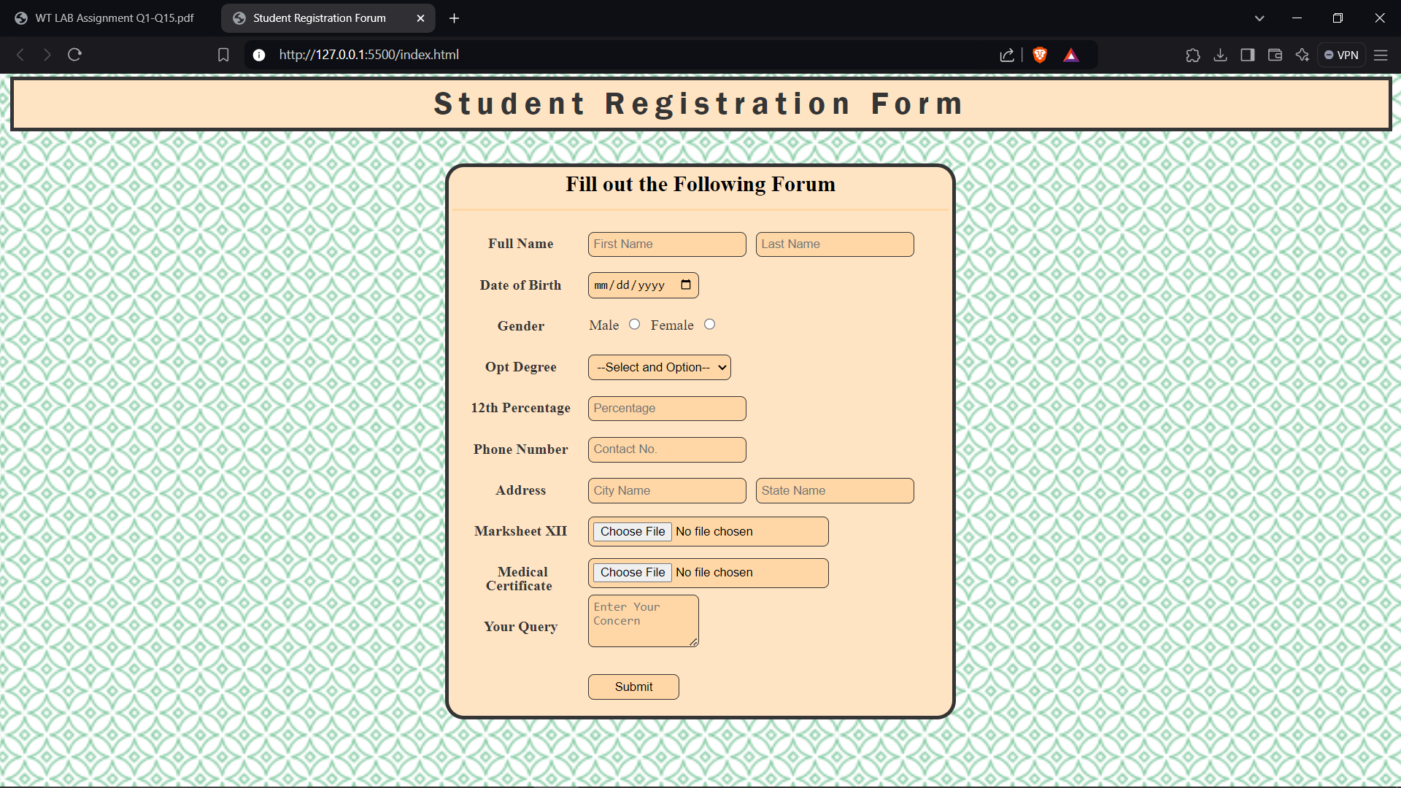

Web Tech Lab Question 7

24th September 2024

Question:

Create a webpage and show the usage of inline, internal and external stylesheets.

SOURCE CODE:

HTML

index.html

<!DOCTYPE html>

<html lang="en">

<head>

    <meta charset="UTF-8">

    <meta name="viewport" content="width=device-width, initial-scale=1.0">

    <title>Types of Stylesheet</title>

</head>

<frameset rows="*,*,*">

    <frame src="./frame1.html">

    <frame src="./frame2.html">

    <frame src="./frame3.html">

</frameset>

<body>

</body>

</html>

frame1.html

<!DOCTYPE html>

<html lang="en">

<head>

    <meta charset="UTF-8">

    <meta name="viewport" content="width=device-width, initial-scale=1.0">

    <title>Inline CSS</title>

</head>

<body>

    <h1 style="text-align: center; ">Using <u>Inline</u> type of CSS</h1>

    <div style=" margin-left: 350px ; width: 50vw; border: 2px solid black; border-radius: 1.5rem; background-color: grey;">

        <p style="margin-left: 20px; font-size: larger;">In this frame we are using Inline CSS</p>

        <p style="margin-left: 20px; font-size: larger;">When we individualy style every tag using 'style' attribute, it is known as Inline Styling.</p>

    </div>

    <h4 style="margin-left: 350px;">*for every element in this frame individual Inline Styling has been provided.</h4>

</body>

</html>

frame2.html

<html lang="en">

<head>

    <title>Internal CSS</title>

    <style>

        body{

            background-color: rgb(6, 2, 21);

        }

        h1{

            text-align: center;

            color: beige;

        }

        div{

            margin-left: 350px;

            width: 50vw;

            border: 2px solid beige;

            border-radius: 1.5rem;

            background-color: grey;

        }

        p{

            margin-left: 20px;

            font-size: larger;

            color: beige;

        }

        h4{

            color: beige;

            margin-left: 350px;

        }

    </style>

</head>

<body>

    <h1>Using <u>Internal</u> type of CSS</h1>

    <div>

        <p >In this frame we are using Internal CSS</p>

        <p >When CSS is written within the script tag inside of head tag, it is known as Internal Styling.</p>

    </div>

    <h4>*for every element in this frame Internal Styling has been provided in head tag.</h4>

</body>

</html>

frame3.html

<!DOCTYPE html>

<html lang="en">

<head>

    <meta charset="UTF-8">

    <meta name="viewport" content="width=device-width, initial-scale=1.0">

    <title>Internal CSS</title>

    <link rel="stylesheet" href="style.css">

</head>

<body>

    <h1>Using <u>External</u> type of CSS</h1>

    <div>

        <p>In this frame we are using External CSS</p>

        <p>When CSS is written in an external text file with .css extension and is linked with the current html file using link tag is known as External CSS.</p>

    </div>

    <h4>*for every element in this frame External Styling has been provided in style.css file.</h4>

</body></html>

style.css

h1{

    text-align: center;

    color: black;

}

div{

    margin-left: 350px;

    width: 50vw;

    border: 2px solid black;

    border-radius: 1.5rem;

    background-color: grey;

}

p{

    margin-left: 20px;

    font-size: larger;

    color: black;

}

h4{

    color: black;

    margin-left: 350px;

}

OUTPUT:

